PIZZA SALES ANALYSIS DASHBOARD
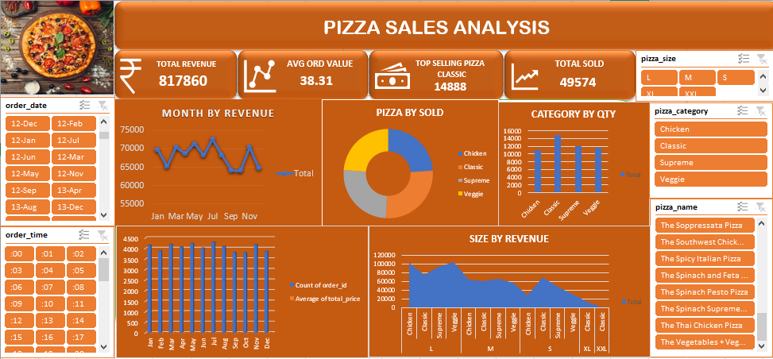
KPI’S
- TOTAL REVENUE
SELECT ROUND(SUM(total_price)) AS TotalRevenue
FROM SWIGGY;
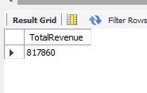
- Average Order Value
SELECT ROUND(SUM(total_price)/COUNT(DISTINCT order_id),2) AS Average_order_value
FROM SWIGGY;
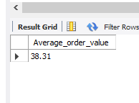
3.Top-Selling Pizza
SELECT pizza_category,SUM(quantity) AS Total_quantity_sold
FROM SWIGGY
GROUP BY pizza_category
ORDER BY Total_quantity_sold DESC
LIMIT 1;
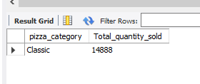
4.Category Performance
SELECT pizza_category,SUM(quantity) AS TotalquantitySold
FROM SWIGGY
GROUP BY pizza_category;
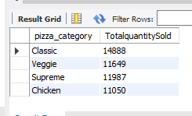
5.Sales by Pizza Size
SELECT pizza_size,SUM(quantity) AS Total_sold
FROM SWIGGY
GROUP BY pizza_size
ORDER BY Total_sold DESC;
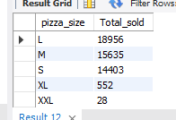
6.TOTAL SOLD
SELECT SUM(quantity) AS Total_Sold
FROM SWIGGY;
PROBLEM STATEMENT
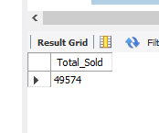
Average Order Value by Month
SELECT
DATE_FORMAT(order_date, '%Y-%m') AS month,
ROUND(SUM(total_price) / COUNT(DISTINCT order_id), 2) AS average_order_value
FROM SWIGGY
GROUP BY DATE_FORMAT(order_date, '%Y-%m')
ORDER BY month;
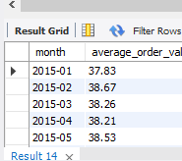
Average Order Value by Day of Week
SELECT
DAYNAME(order_date) AS day_of_week,
ROUND(SUM(total_price) / COUNT(DISTINCT order_id), 2) AS average_order_value
FROM SWIGGY
GROUP BY DAYNAME(order_date)
ORDER BY FIELD(day_of_week, 'Monday', 'Tuesday', 'Wednesday', 'Thursday', 'Friday', 'Saturday', 'Sunday');
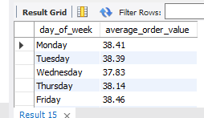
DATA REQUIRE LINK
https://drive.google.com/drive/folders/1ecpBALfFUMSK-GOnk-X4nZhC_uK18zih
PRESENTATION PPT LINK
https://www.canva.com/design/DAG37rSqbVI/BSHRbJIE2AudIeJy0aV0DA/view?utm_content=DAG37rSqbVI&utm_campaign=designshare&utm_medium=link2&utm_source=uniquelinks&utlId=h0bb5861694

